Volunteer Information Evening

Could you open up your home to prevent a young person from sleeping on the streets?
If this is something you have thought about doing but unsure of how to go about it
This evening is for YOU!

Come and hear about the exciting work of Open Homes Supported Lodgings Scheme and Nottingham Nightstop.

Nottingham Nightstop provides young people aged 16-25, at risk of homelessness, safe emergency overnight accommodation in the homes of trained volunteer host families.

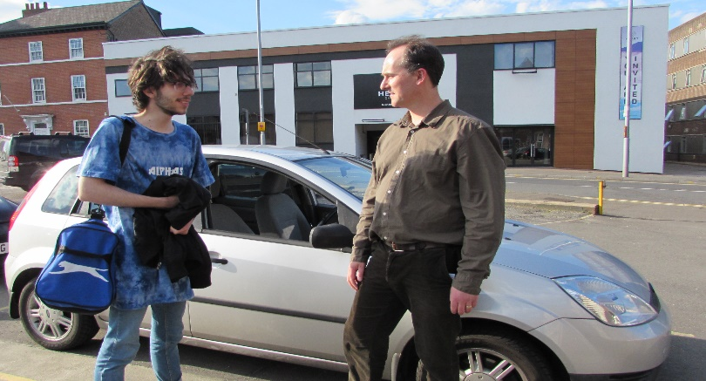

Supported Lodgings hosts provide accommodation in a similar setup to Nottingham Nightstop but as a move-on option for young people who have been hosted through Nightstop. The young person stays with the host for a few months instead of a few nights.

The evening will include
A presentation on the work of Open Homes and the projects it runs
Input from current Hosts and Drivers
Information on volunteer roles and opportunities
Refreshments will be served

Date: Wednesday 13th March 2019 Time: 7.30pm

Location: Cornerstone Church, 90 Castle Boulevard, Nottingham, NG7 1FP
(onsite parking available)

For further information please go to the Open Homes Nottingham website
www.openhomes.org.uk or telephone 0333 3232 265 or email info@nottinghamnightstop.org.uk

